**Lab 1 - AWS ECS**

**Creating Cluster**

1. Search ECS service -> Click on Cluster -> Create Cluster

2. Enter Cluster Name.

3. Select default VPC and subnets or you can select your own VPC and subnets.

4. Select Amazon EC2 Instances checkbox and fill up the required information for autoscaling group

5. Click on Create

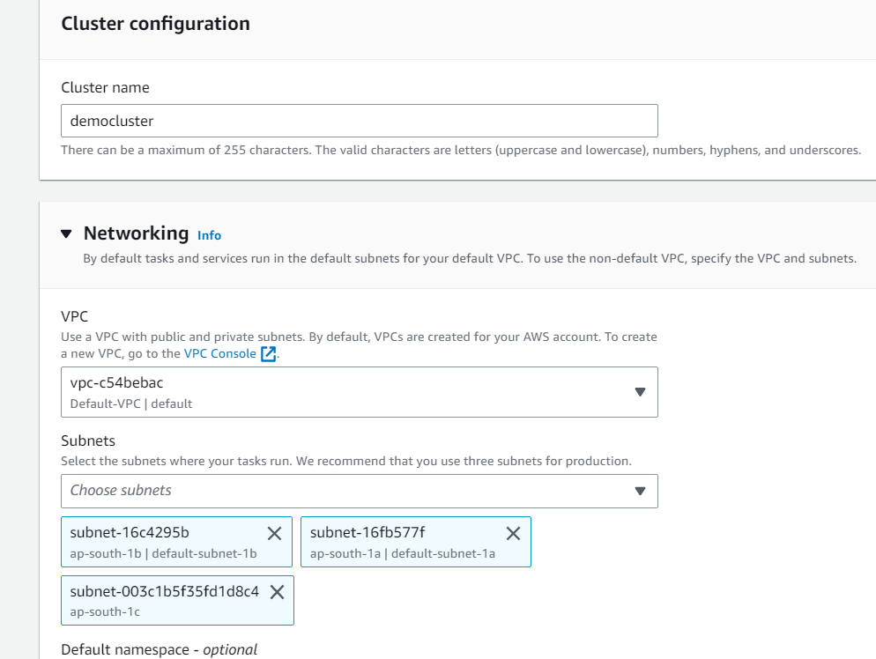

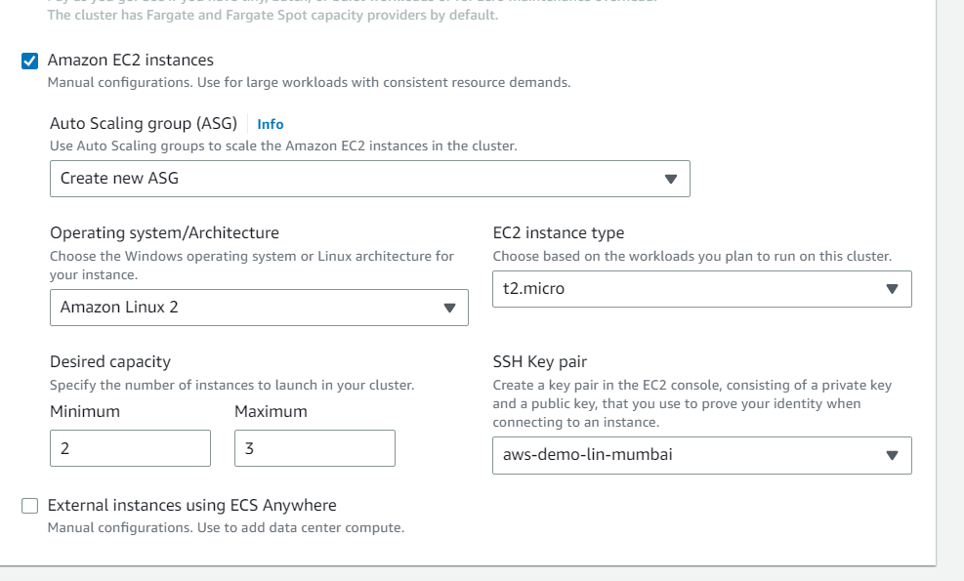

3. **Validation Steps**:

1. Make sure cluster is in active state.

2. Make sure, two instances are in running state.

**Creating Task Definition**

1. Click on Task Definition -> Create new task definition -> EC2 -> Next Step

2. Enter container name, image URI and container port etc

3. Provide all required details. Please refer the below screenshots for reference.

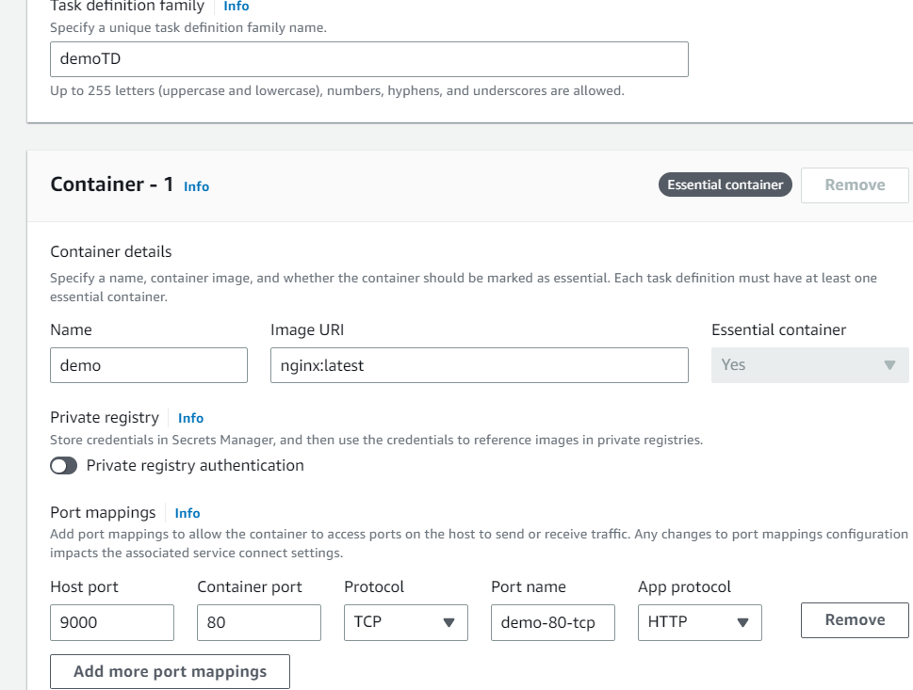

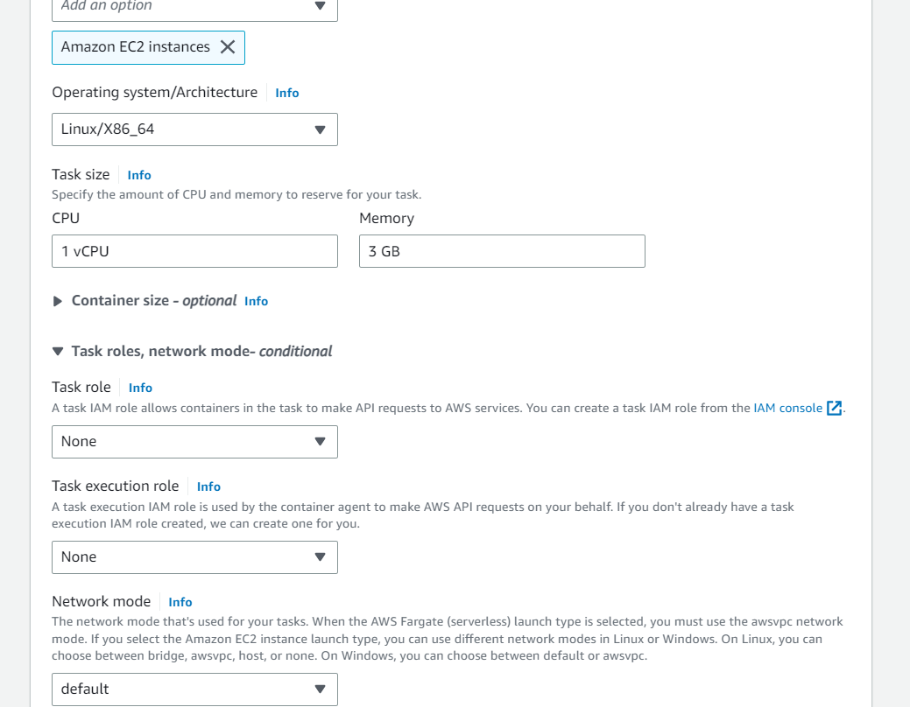

4. Make sure container definition gets added

5. Go to your cluster and Click on create service

6. Enter details as below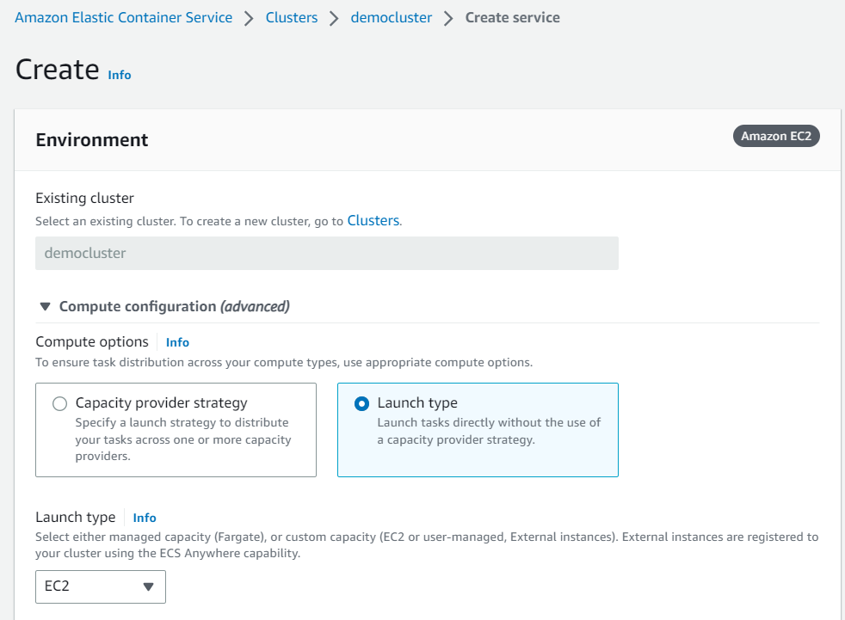

7. Provide details about service as mentioned below

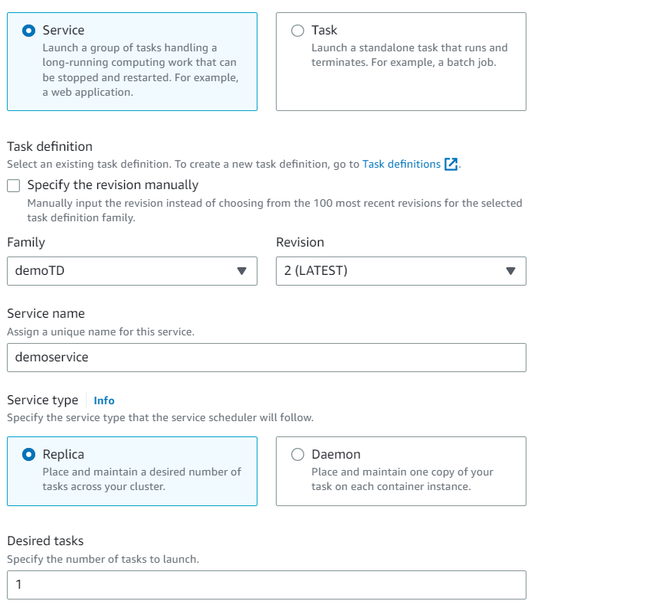

8. Click on create service

**Validation Steps:**

1. Verify two tasks or containers are in running state.

2. Open EC2 host public IP with port 9000 and verify you are able to open the nginx web page which is running on 80 in container.

e.g. <http://public_IP:9000>

**Lab 2 - AWS ECS with AWS ECR**

**Note** – *Use same above lab for this. Make sure, you should have one nginx image pushed to ECR. Please refer the docker registry lab for more details on how to push image to ECR*.

1. Go to task definition and create new version
2. Update Image URI with ECR repo and tag URL

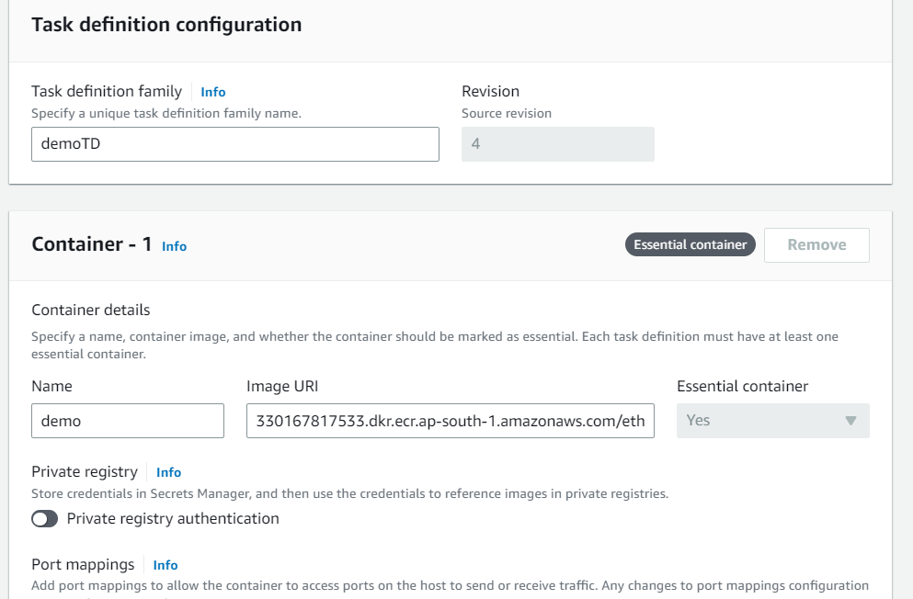

1. Click on create
2. Go to service and do the force deployment with latest new task definition

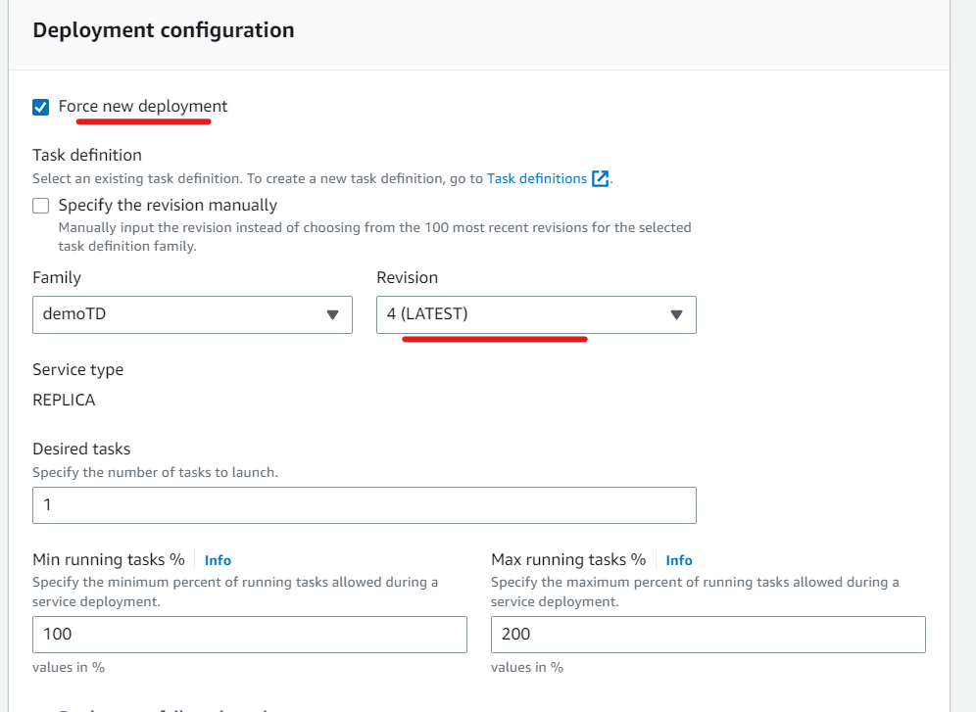

1. There should new task running with new task definition version.
2. Verify whether nginx web page is able to acess by public ip and port 9000